IVAN GASTELU NINALAYA

Lima - Perú

+51992621622

[gastelu.n.ivan@gmail.com](mailto:gastelu.n.ivan@gmail.com)

<https://gasteluivan.github.io>

# SUMMARY

|  |
| --- |
| Hi, I am Ivan Gastelu Ninalaya, and I would like to introduce myself as someone who is always willing to learn and grow, both personally and professionally. I am a committed, passionate, and responsible person, with a goal-oriented focus and an open mindset towards new challenges and opportunities.  My work experience has allowed me to develop skills such as teamwork, adaptability to changing environments, problem-solving, organization, and deadline management. Additionally, I consider myself a creative and initiative person who is always searching for new ideas and ways of doing things.  Regarding my academic background, I have a solid foundation as a web, application, and video game developer, which has contributed to my personal and professional development.  In my free time, I enjoy researching new technology, which has allowed me to maintain balance in my life and develop skills and values such as discipline, perseverance, and creativity.  I am confident that my positive attitude and commitment to work will allow me to effectively contribute to any project or team in which I participate. Thank you for your time and consideration, and I look forward to any opportunities that may arise. |

# KNOWLEDGE

## Software

* Database: MySQL, María DB, Firebase, MongoDB
* Platforms: Windows, Mac, Linux
* Programming languages: C#, JavaScript, PHP, Dart
* Frameworks: WordPress, Joomla, React, Flutter, Phaser 3, Vue JS, Reveal JS, CodeIgniter, Laravel
* Others: Webpack, HTML5, CSS, SASS, PUG, C4D, 3D Max, Unity 3D, Adobe XD, Animate CC, Dragon Bones, Rive, SVGator, WebGl, Tree JS, Illustrator, Photoshop, InDesign, Premier-Pro, After Effects, MS Office, computer repair and maintenance.

## Languages

* English (Intermediate B+)
* Spanish (Native language)

# EXPERIENCE

|  |  |
| --- | --- |
| Analyst and Digital Area Manager | 2015 – 2022 |

FACTORIA MEDIA ESTUDIO (Lima – Perú)

* Video Game Development,
* APP’s, (AR, Story tales)
* Platforms E-learning,
* Responsive Web
* Interactive courses - E-learning
* Animated and interactive stories

|  |  |
| --- | --- |
| Analyst Programmer Animator | 2012 - 2014 |

KRAKEN DESIGN (LIMA – PERÚ)

* Character and scenario animations in Adobe Flash
* Interaction development and scenario layout in ActionScript 2 and 3
* 2D and 3D character and scene design

|  |  |
| --- | --- |
| Security and customer service | 2008 - 2009 |

Ocean Club Community Association, INC (Miami – Florida)

* Front Desk security - Lake Tower electronic building security control and management.
* Administration and control of entry of residents' visits to the tower.

|  |  |
| --- | --- |
| Valet Parking Attendant | 2007 - 2008 |

Grand Bay Club - Torre II (Miami – Florida)

* Reception, care and parking of all types of automobiles.

|  |  |
| --- | --- |
| Ornamental Plants Care and Maintenance | 2006 - 2007 |

Nursery – Homestead (Miami – Florida)

* Care and sprayer for chemicals.

|  |  |
| --- | --- |
| Livestock Worker Ranch Hand | 2004 - 2006 |

Cross Mountain Ranch (Craig – Colorado)

* Handling of heavy machinery for planting and harvesting grass in summer.
* Cattle sanitary and reproductive management
* Care, feeding and fattening of cattle

|  |  |
| --- | --- |
| Electronics trainee repair of electronic equipment | 2002 - 2003 |

Electrónica Ruttie - (Lima – Perú)

* Repairs of electronic equipment TV, Radios, etc.

# EDUCATION

|  |  |
| --- | --- |
| TOLOUSE LAUTREC Santiago de Surco – Lima Perú   * Web and Multimedia Designer | 2010 - 2013 |

|  |  |
| --- | --- |
| SENSICO Huancayo Junín – Lima Perú   * Graphic design and Web development | 2000 - 2001 |

|  |  |
| --- | --- |
| SENATI Huancayo Junín – Lima Perú   * Web and Multimedia Developer | 1999 - 2000 |

|  |  |
| --- | --- |
| GAMOR CETPRO Cercado de Lima – Perú   * Electronics - Repair of electronic equipment. | 1998 - 1999 |

# DOCUMENTATION

**Toulouse Lautrec**

SENSICO

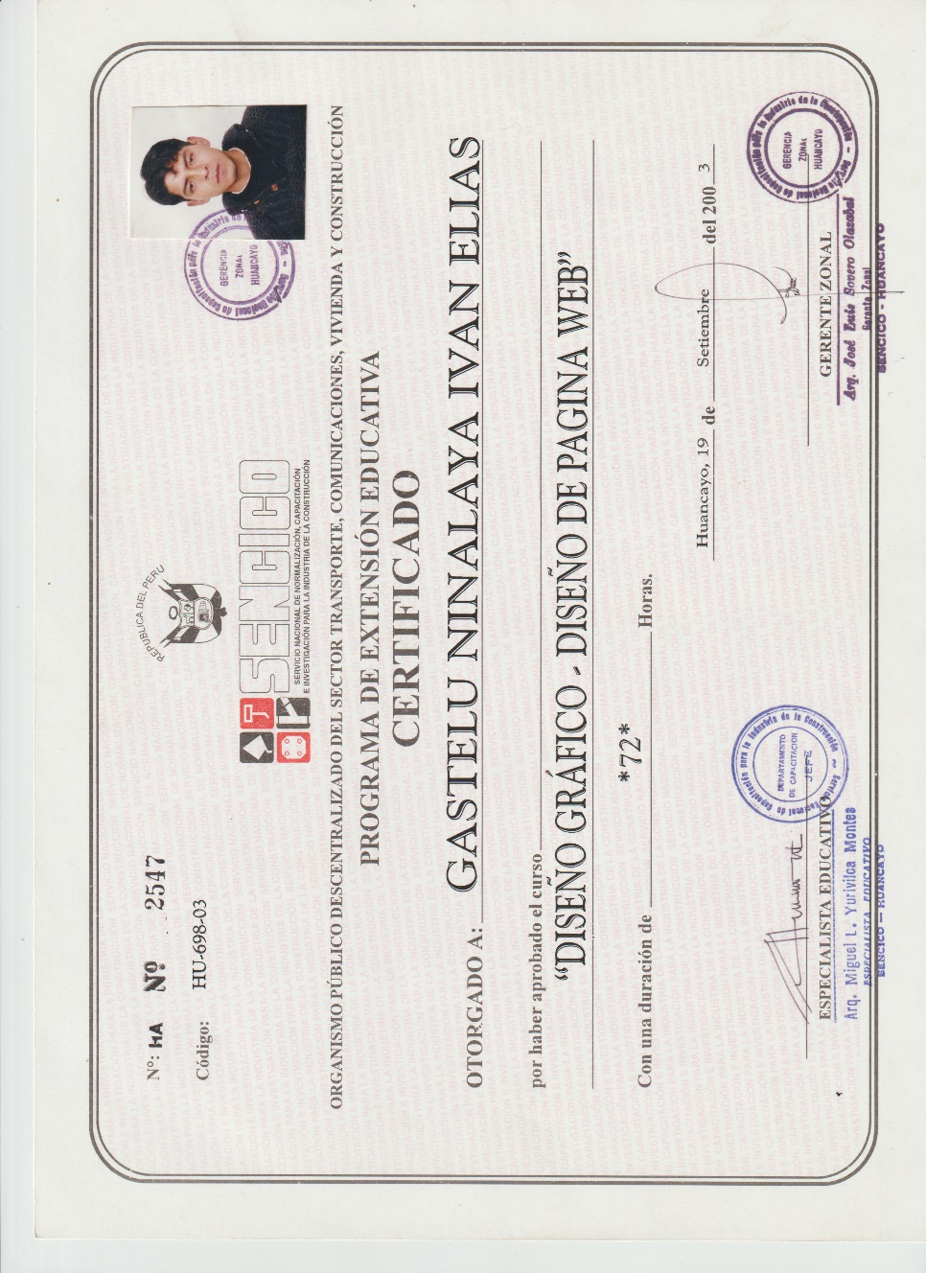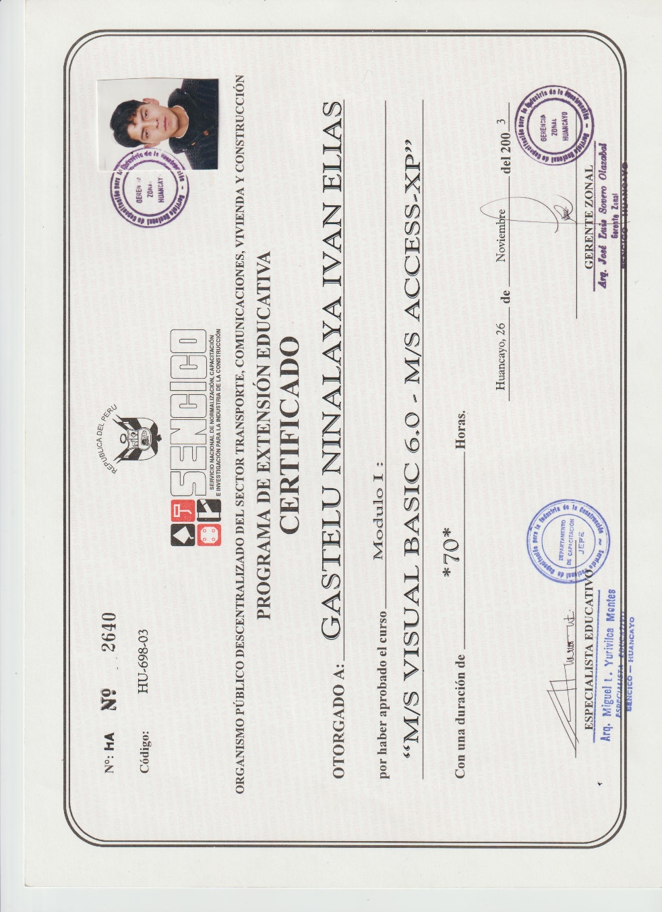

SENATI

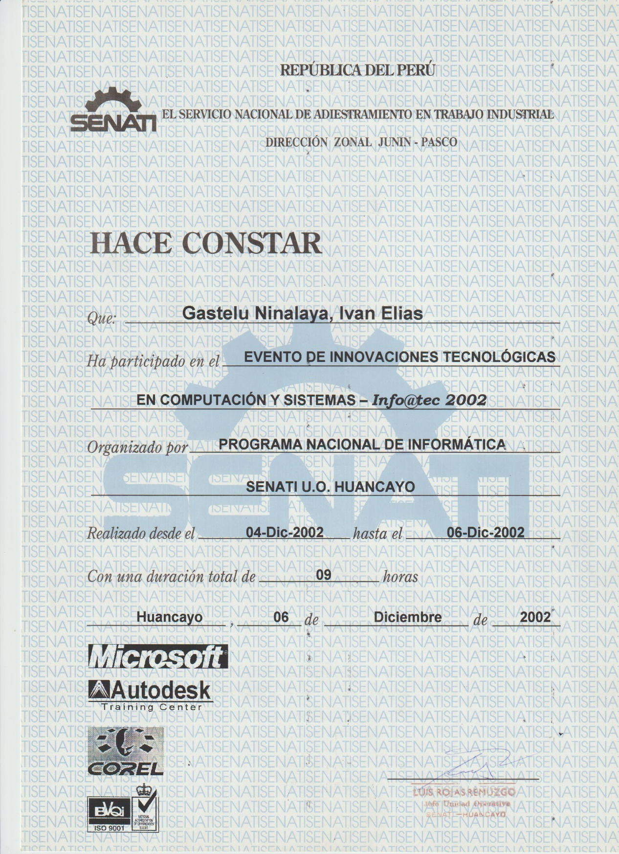

GAMOR



OTROS

